

*Car Rental Booking*

**E-Project Documentation**

**Teacher Name: Sir Asees**

**APTECH COMPUTER EDUCATION**

**HYDERABAD-1 PAKISTAN**

**Issue Date: -13-Oct-2023**

TABLE OF CONTENT

|  |  |  |
| --- | --- | --- |
| **S No** | **Contents** | **Page No** |
| 01 | Certificate | 3 |
| 02 | Acknowledgement | 4 |
| 03 | Project Report | 5 |
| 04 | Problem Statement | 6 |
| 05 | Customer Requirements Specification (CRS) | 8 |
| 07 | System Requirement | 10 |
| 08 | Task Sheet | 11 |
| 09 | Project Plan | 13 |
| 10 | Checklist of work Progress | 18 |
| 11 | Screen Shots | 17 |
| 12 | Source Code | 25 |

CERTIFICATE

This is to certify that

**Nimra Rajput, Shahbaz Ali ,Zainab khan**

Has successfully Designed

Car Rental Booking

Submitted by:

**Nimra Rajput, Shahbaz Ali ,Zainab khan**

Date of Issue: 13-Oct-2023

**Authorized Signature:** Sir Asees

ACKNOWLEDGEMENT

The thirst for learning, upgrading technical skills and applying the concepts in real life environment at a fast pace is what the industry demands from IT professionals today. However busy work schedules, far-flung locations, unavailability of convenient time-slots pose as major barriers when it comes to applying the concepts into realism. And hence the need to look out for alternative means of implementation in the form of laddered approach.

The above truly pose as constraints especially for our students too! With their busy schedules, it is indeed difficult for our students to keep up with the genuine and constant need for integrated application which can be seen live especially so in the field of IT education where technology can change on the spur of a moment. *Well, technology does come to our rescue at such times!!*

Keeping the above in mind and in tune with our constant endeavour to use Technology in our training model, we at Aptech have thought of revolutionizing the way our students learn and implement the concepts using tools themselves by providing a *live and synchronous eProject learning environment!*

PROJECT REPORT

**Project Title: Car Rental Booking**

**Members Name: Nimra Rajput, Shahbaz Ali ,Zainab khan**

**Batch Code: 2103D**

**Start Date: 16-Oct-2023**

**End Date: 7-Nov-2023**

**Course: ACCP (ADSE)**

**Teacher: Sir Asees**

**Center Manager: Sir Shoaib Ahmed**

**Center Academic Head: Sir Zubair**

**Center Name ACE Hyderabad-1, Pakistan**

Submitted as

E Project Documentation

**PROBLEM STATEMENT**

Problem statement is attached separately in a file “**E-Books**”

**Standards plan:**

Every code block must have comments.

The logic of the program needs to be explained. Proper documentation should be maintained.

Complete Project Report along with synopsis, code and documentation should be prepared.

**Documentation:**

No project is complete without documentation. In fact, it is one of the most important activities during the development of a project. The documentation of an ideal project will be in the form of a project report comprising of the following documents:

* Certificate of Completion.
* Table of Contents.
* Problem Definition.
* Customer Requirement Specification.
* Project Plan.
* E-R Diagrams.
* Algorithms.
* GUI Standards Document.
* Interface Design Document.
* Task Sheet.
* Project Review and Monitoring Report.
* Unit Testing Check List.
* Final Check List.

**Customer Requirement Specification**

eProject is a step by step learning environment that closely simulates the classroom and Lab based learning environment into actual implementation. It is a project implementation at your fingertips!! An electronic, live juncture on the machine that allows you to

* Practice step by step i.e. laddered approach.
* Build a larger more robust application.
* Usage of certain utilities in applications designed by user.
* Single program to unified code leading to a complete application.
* Learn implementation of concepts in a phased manner.
* Enhance skills and add value.
* Work on real life projects.
* Give a real life scenario and help to create applications more complicated and useful.
* Mentoring through email support.

The students at the centre are expected to complete this eProject and send complete documentation with source code to eProjects Team

Looking forward to a positive response from your end!!

**Objectives of the project**

The Objective of this program is to give a sample project to work on real life projects. These applications help you build a larger more robust application.

The objective is not to teach you concepts but to provide you with a real life scenario and help you create applications using the tools.

You can revise them before you start with the project.

It is very essential that a student has a clear understanding of the subject.

Kindly get back to eProjects Team in case of any doubts regarding the application or its objectives.

System Requirement:

**Hardware**

* A minimum computer system that will help you access all the tools in the courses is a Pentium 166 or better
* 128 Megabytes of RAM or better

**Operating System**

* LINUX / Windows 2000 Server (or higher if possible)

**Software**

* Python
* R-Language
* Django

TASK SHEET

|  |  |  |  |  |  |
| --- | --- | --- | --- | --- | --- |
| **Project Ref. No:** | | **Date of Preparation of Activity Plan:** | | | |
| SR.  No | Task | Actual  Start  Date: | Actual  Day: | Team  Mates  Names: | Status: |
| 01 | **Planning** | 16-Oct-2023 | 2 | Nimra,Shahbaz Ali,Zainab | YES |
| 02 | **Data Collection** | 18-Oct-2023 | 5 | Nimra,Shahbaz Ali,Zainab | YES |
| 03 | **Web page designing** | 21-Oct-2023 | 5 | Nimra,Shahbaz Ali,Zainab | YES |
| 04 | **Database** | 25-Oct-2023 | 2 | Nimra,Shahbaz Ali,Zainab | YES |
| 05 | **Admin Panel** | 28-Oct-2023 | 2 | Nimra,Shahbaz Ali,Zainab | YES |
| 06 | **Checkout system** | 30-Oct-2023 | 2 | Nimra,Shahbaz Ali,Zainab | YES |
| 07 | **Search & subscription System** | 01-Nov-2023 | 1 | Nimra,Shahbaz Ali,Zainab | YES |
| 08 | **Testing** | 05-Nov-2023 | 1 | Nimra,Shahbaz Ali,Zainab | YES |
| 09 | **Documentation** | 07-Nov -2023 | 1 | Nimra,Shahbaz Ali,Zainab | YES |
| 10 | **Uploading** | 14-Nov-2023 | 1 | Nimra,Shahbaz Ali,Zainab | YES |

PROJECT PLAN

*Existing Scenario: –*

The publisher (client) usually publishes in the form of a hard copy (books) and in the form of a CD and distributes them to the book dealers situated all over the city, who distributes the books to the public at the maximum retail price. Sometimes the dealers come up saying that they want more number of copies and they again need to print the books and redistribute among the dealers based on the request of the dealers. So it takes some time in distributing the books among the dealers and then to the customers. Also he announces about the essay writing competitions, story competitions on the journal for which three days are given for the receipt of the essay writings and for the story receipt they are needed to be sent within a week in order to attract the customers and he provides the prizes as per the competition and the winner topic and the story or the essay that he/she has sent will be published in the next publication (journal or the essay book)

*Proposed Solution:* –

In order to attract and retain the customers, and to reach out to the customers early, and to stand by in this competitive world the publisher wants to build a website where the customers can register with the site and they can avail the membership benefits like getting some of the books free of cost in the form of a PDF document and as well they can place a request for purchase through online either in the form of the PDF document or in the form of a CD or in the form of a hard copy. There by reducing the delay in sending the copy to the customer as it will be directly sent to the customer’s address, instead of sending it to the book dealer and then to the customer.

The ones who purchases the book online in the form of a PDF document can have the benefits like they can access the book online and they can get the updated details as they can subscribe for a year or two or three depending on how often the book is revised. As well the PDF document that is purchased through online can only be accessed and downloaded from the site only after the receipt of the payment by the publisher.

Also the details of the books are needed mentioned including the details of the payments (includes the shipping charges (applicable for the order for a hard copy or CD and weight of that copy) or subscription charges and as well the original price of the book), Author, brief description of the book like about the book, etc…. The client says that the registered users should only be able to fetch and see the details of the books and they can alone place the order for the book.

Also he says that he want to announce the competitions for the journal and also the registered users can submit their story online through a link where one can upload the document and so that they can participate for the competition and the winners will be provided with the prize and the details of the winners will be displayed on the home page of the website. The details of the Essay writings or competitions for the journals like the date of commencing (displayed a week before of commencing), winners for the previous and the current competitions, prizes for that competition, etc…. will be displayed on the home page.

Also he says that in order to entertain children he wants to implement essay writing competition for which the topics will be provided in a separate window and the topics are needed to be displayed when it is being accessed and one needs to submit their essay writings within 3 hrs. from the time the page is being accessed and if it is not sent by that time that particular user will not be able to submit or attend for the essay writing. Here also the winners are also announced and displayed on the site and they will be provided with some famous books either for essay writing, or G.K. books or Grammar books.

As soon as a request is placed by the customer for the purchase of a book through online, he will be intimated with a mail from the respective department regarding the order asking for the confirmation of the order placed and will be charged as per the book price and as per the revisions done to that book the customer will be asked to make the payment for the subscription as applicable for that book. And as soon as the payment is received by the publisher they will intimate the customer through mail about the receipt of the payment and as well it will be updated in the site so that the customer can access the document online.

With the varying trends in technology where one can now purchase the books or get them at free of cost online. In order to attract and retain the customers he even

In this current internet trend where one can easily purchase books online and some of the books can be attained at free of cost, so he wanted to attract his customers by providing an online portal where one can find the details of all his publications and as well one can register with the site so as to attain the benefits (like some of the books are provided free of cost for the registered users) and one can place a request for purchase of the books only when they are registered with the site and as well he says that the brief description can be seen by the unregistered users and for the detailed description of the books can be seen by the registered users.

Also the registered user can purchase the book in three types, one in the form of a PDF Document, the other in the form of a hard copy and the other in the form of a CD. For those who have placed the order for hard copy or for a CD, they will be charged for the delivery apart from the book price and it will be based on the place, weight of the book or CD.

►Non-Financial:

* The details of the books are needed to be captured in detail.
* Also the admin (publisher or manager of the publication) can alone have the rights to enter the details of the books like price (either free of cost or some value…), shipment or delivery charges and as well the subscription charges and their brief description.
* The details of the books and as well the details of the customers and the delivery details, shipment details and as well the details of the orders placed are needed to be stored in the database.
* Advanced search option is needed to be included so that the customer can fetch the details.
* The customers should also be able to register with the site.
* On the home page the details of the new releases and the ones that are sold at a very high rate are needed to be mentioned.
* Also the details of the winners for the previous and the current competitions and the details of the competition like the type of the competition and the date of commencing of the competition(s) that are going to be held in the nearby future are also needed to be mentioned on the home page.
* The information about the books, competitions, etc…. will be only be accessed by the registered users and their complete details are to be mentioned in the appropriate link like the competitions link pages, etc……
* There should be a separate navigation link that includes the details of the competition like the topics for the essay writing and the rules and the prizes for that competition
* An advanced search option is needed to be included so that the user can fetch the details at an ease
* The orders are needed to be easily tracked down by the publisher.
* If a customer places an order through online and for a PDF Document then he/she can only be able to access that document only after the payment is received by the publisher.
* Also as soon as the order is place the customer should get the mail from the concerned department stating the receipt of the order and asking for the confirmation and as well the customer is needed to be intimated as soon as the payment is received by the publisher.
* The contact information is also needed to be provided, which includes the details of the dealers of that location, so that the customer can even purchase that book from the dealer.
* The registered customer who wanted to participate in the competition should be able to upload their essay or the story in the form of a document file from that competition link of the website.
* A Timer should be started as soon as the essay writing competition page is opened and if the time crosses 3Hrs. the customer should not be able to participate in the competition

►Financial:

The customers are needed to make their payments either by Credit card or through DD or through Cheque or through VPP. And only after the receipt of the payment they can be able to access the PDF document, if placed an order for the document. Also for participating in the competition there are no charges and as well the winners are to be provided with the prizes as mentioned in the rules for that particular competition.

## PROBLEM STATEMENT

You are tasked with developing a Car Rental System for a local car rental company. The system should provide an online platform for customers to browse available cars, make reservations, and manage their bookings. Additionally, the system should offer administrative functionalities for managing the fleet, tracking reservations, and generating reports.

Functional Requirements:

Customer Portal:

**User Registration and Login:**

Customers should be able to register on the platform with their personal details.

Existing users should be able to log in.

**Browse Available Cars:**

Display a list of available cars with details such as make, model, year, and rental price.

Allow customers to filter and search for cars based on criteria such as type, brand, or price.

**View Car Details:**

Provide detailed information about a selected car, including images, features, and rental terms.

The website will have three users/roles:

1. Admin
2. Register Users
3. Guest

The Admin should be able to do the following:

**Admin**

Admin is the super user of the website who can manage everything on the website. Admin can log in through the login page

* Admin can create vehicle brands
* Manage Vehicle Brands(Edit, Delete)
* Post Vehicle
* Manage vehicle(Edit, Delete)
* Manage Booking(Admin can confirm and Cancel Booking)
* Manage Testimonials (Active and Inactive)
* Manage to Contact us Query
* Admin Can the details of registered users
* admin can also update the page content
* Admin can update the contact us details
* Manage Subscribers
* Admin Dashboard (Admin can view the count of registered users, total booking, total subscribers, total queries, etc.)
* Change Password(admin can change own password)
* logout

The Register Users should be able to do the following:

**Register Users**

* Anyone can register through the registration page.
* After a successful registration user can log in with valid email and password. User can recover own password by providing some registered info.
* After successful login user can do the following things–
  + Car Booking
  + View Car booking history
  + Update His/Her profile
  + Update his/her password
  + Post Testimonials
  + View Testimonials
  + Logout

The Guest Users should be able to do the following:

**Guest Users**

* Guest user can view the website and check out the information about rental cars.
* Guest users can also inquiry through contact us page.

CHECK LIST OF WORK PROGRESS

|  |  |  |
| --- | --- | --- |
| **S.No** | **Aspect Tested** | **Remarks** |
| 01 | Data Collection | **Yes** |
| 02 | Designing Home Page | **Yes** |
| 03 | Database | **Yes** |
| 04 | Amin panel | **Yes** |
| 05 | Linking The Pages | **yes** |
| 06 | Finalization | **Yes** |
| 08 | Testing The Site | **Yes** |
| 09 | Documentation | **yes** |

SCREEN SHOTS

Home Page

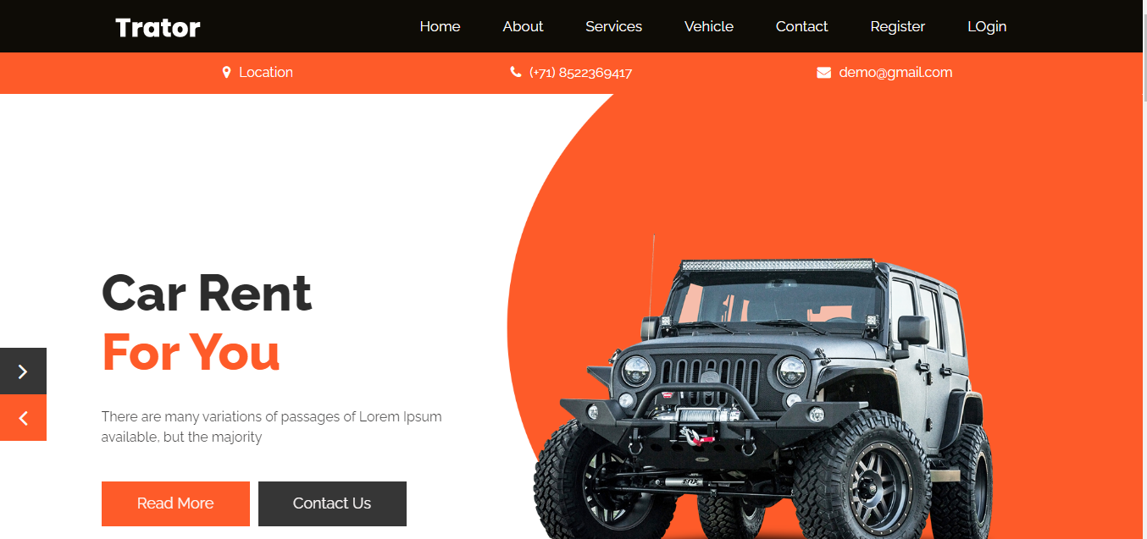

Dashboard

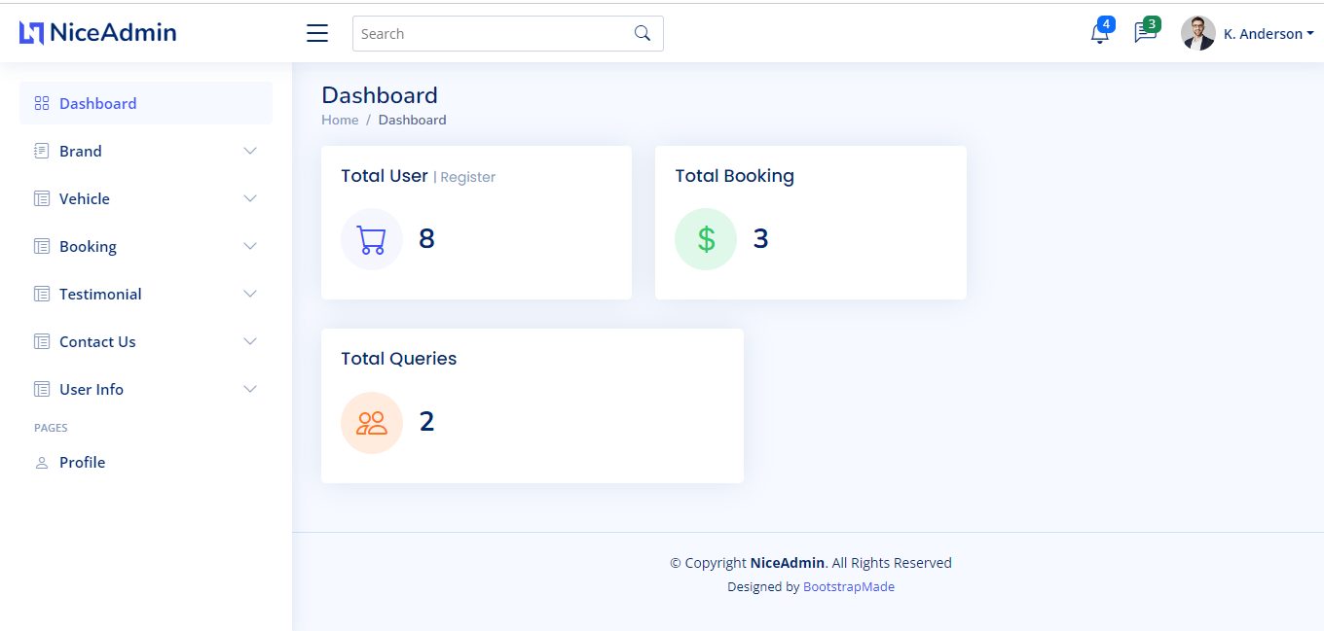

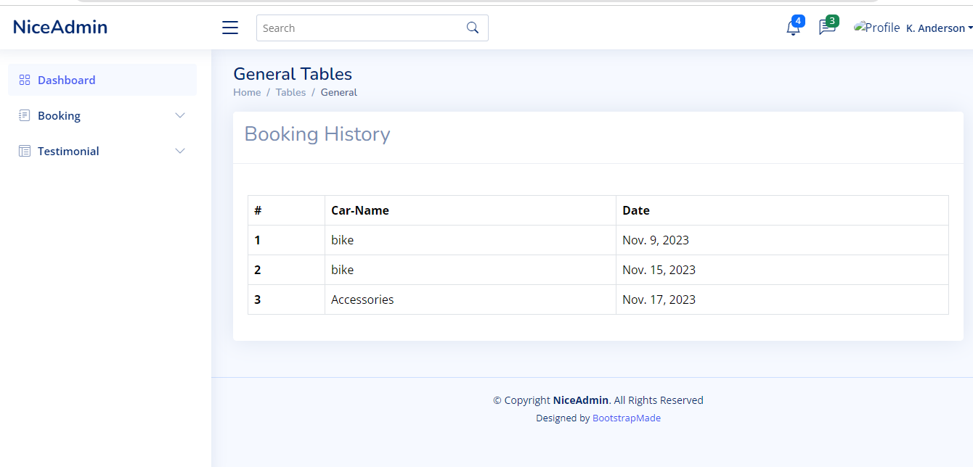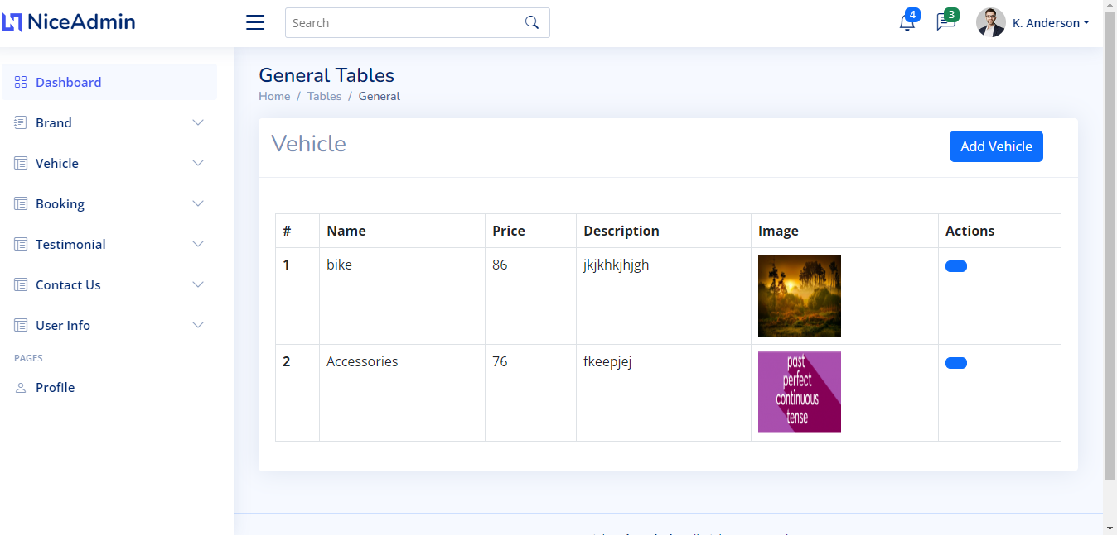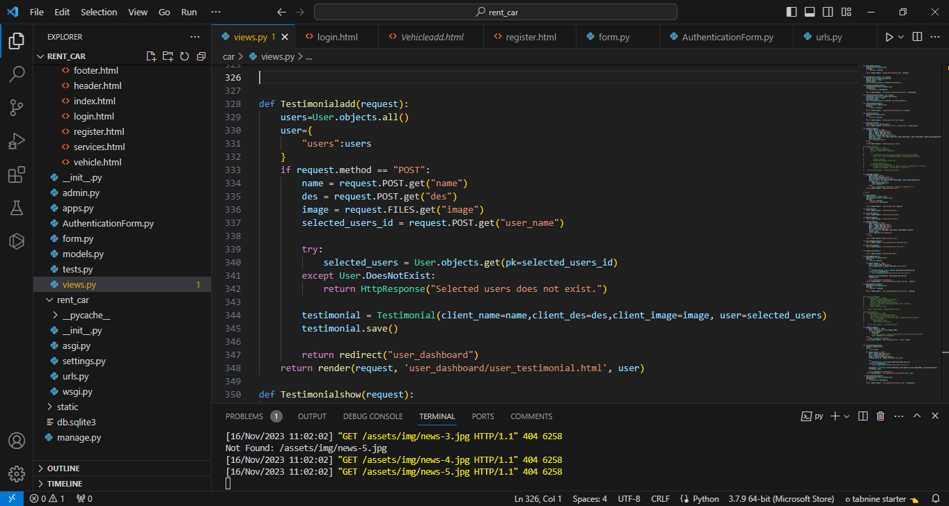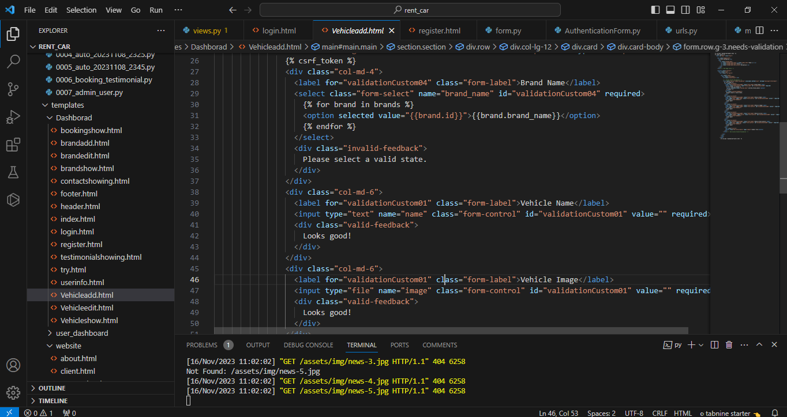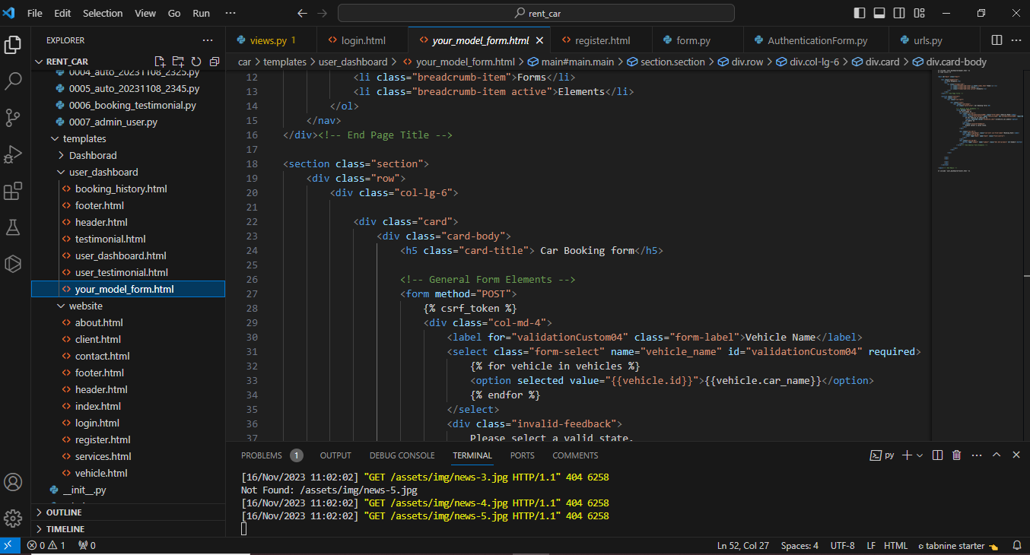

SOURCE CODE

Index-page

{% include 'website/header.html' %}

{% load static %}

      <!-- banner section start -->

      <div class="banner_section layout_padding">

         <div class="container">

            <div class="row">

               <div class="col-md-6">

                  <div id="banner_slider" class="carousel slide" data-ride="carousel">

                     <div class="carousel-inner">

                        <div class="carousel-item active">

                           <div class="banner_taital_main">

                              <h1 class="banner_taital">Car Rent <br><span style="color: #fe5b29;">For You</span></h1>

                              <p class="banner_text">There are many variations of passages of Lorem Ipsum available, but the majority</p>

                              <div class="btn_main">

                                 <div class="contact_bt"><a href="#">Read More</a></div>

                                 <div class="contact_bt active"><a href="#">Contact Us</a></div>

                              </div>

                           </div>

                        </div>

                        <div class="carousel-item">

                           <div class="banner_taital_main">

                              <h1 class="banner_taital">Car Rent <br><span style="color: #fe5b29;">For You</span></h1>

                              <p class="banner_text">There are many variations of passages of Lorem Ipsum available, but the majority</p>

                              <div class="btn_main">

                                 <div class="contact_bt"><a href="#">Read More</a></div>

                                 <div class="contact_bt active"><a href="{% url 'contact' %}">Contact Us</a></div>

                              </div>

                           </div>

                        </div>

                        <div class="carousel-item">

                           <div class="banner_taital_main">

                              <h1 class="banner_taital">Car Rent <br><span style="color: #fe5b29;">For You</span></h1>

                              <p class="banner_text">There are many variations of passages of Lorem Ipsum available, but the majority</p>

                              <div class="btn_main">

                                 <div class="contact_bt"><a href="#">Read More</a></div>

                                 <div class="contact_bt active"><a href="{% url 'login' %}">Contact Us</a></div>

                              </div>

                           </div>

                        </div>

                     </div>

                     <a class="carousel-control-prev" href="#banner_slider" role="button" data-slide="prev">

                        <i class="fa fa-angle-left"></i>

                     </a>

                     <a class="carousel-control-next" href="#banner_slider" role="button" data-slide="next">

                        <i class="fa fa-angle-right"></i>

                     </a>

                  </div>

               </div>

               <div class="col-md-6">

                  <div class="banner_img"><img src="{% static '/website/images/banner-img.png' %}"></div>

               </div>

            </div>

         </div>

      </div>

      <!-- banner section end -->

      <!-- about section start -->

      <div class="about_section layout_padding">

         <div class="container">

            <div class="about_section_2">

               <div class="row">

                  <div class="col-md-6">

                     <div class="image_iman"><img src="{% static '/website/images/about-img.png' %}" class="about_img"></div>

                  </div>

                  <div class="col-md-6">

                     <div class="about_taital_box">

                        <h1 class="about_taital">About <span style="color: #fe5b29;">Us</span></h1>

                        <p class="about_text">going to use a passage of Lorem Ipsum, you need to be sure there isn't anything embarrassing hidden in the middle of text. All the Lorem Ipsum generators on the Internet tend to repeat predefined going to use a passage of Lorem Ipsum, you need to be sure there isn't anything embarrassing hidden in the middle of text. All the Lorem Ipsum generators on the Internet tend to repeat predefined </p>

                        <div class="readmore_btn"><a href="#">Read More</a></div>

                     </div>

                  </div>

               </div>

            </div>

         </div>

      </div>

      <!-- about section end -->

      <div class="search_section">

         <div class="container">

            <div class="row">

               <div class="col-md-12">

                  <h1 class="search_taital">Search Your Best Cars</h1>

                  <p class="search_text">Using 'Content here, content here', making it look like readable</p>

                  <!-- select box section start -->

                  <div class="container">

                     <div class="select_box_section">

                        <div class="select_box_main">

                           <div class="row">

                              <div class="col-md-3 select-outline">

                                 <select class="mdb-select md-form md-outline colorful-select dropdown-primary">

                                    <option value="" disabled selected>Any Brand</option>

                                    <option value="1">Option 1</option>

                                    <option value="2">Option 2</option>

                                    <option value="3">Option 3</option>

                                 </select>

                              </div>

                              <div class="col-md-3 select-outline">

                                 <select class="mdb-select md-form md-outline colorful-select dropdown-primary">

                                    <option value="" disabled selected>Any type</option>

                                    <option value="1">Option 1</option>

                                    <option value="2">Option 2</option>

                                    <option value="3">Option 3</option>

                                 </select>

                              </div>

                              <div class="col-md-3 select-outline">

                                 <select class="mdb-select md-form md-outline colorful-select dropdown-primary">

                                    <option value="" disabled selected>Price</option>

                                    <option value="1">Option 1</option>

                                    <option value="2">Option 2</option>

                                    <option value="3">Option 3</option>

                                 </select>

                              </div>

                              <div class="col-md-3">

                                 <div class="search_btn"><a href="#">Search Now</a></div>

                              </div>

                           </div>

                        </div>

                     </div>

                  </div>

                  <!-- select box section end -->

               </div>

            </div>

         </div>

      </div>

      <!-- gallery section start -->

      <div class="gallery_section layout_padding">

         <div class="container">

            <div class="row">

               <div class="col-md-12">

                  <h1 class="gallery_taital">Our best offers</h1>

               </div>

            </div>

            <div class="gallery_section_2">

               <div class="row">

                  <div class="col-md-4">

                     <div class="gallery_box">

                        <div class="gallery_img"><img src="{% static '/website/images/img-1.png' %}"></div>

                        <h3 class="types_text">Toyota car</h3>

                          <p class="looking_text">Start per day $4500</p>

                        <div class="read_bt"><a href="{% url 'login' %}">Book Now</a></div>

                     </div>

                  </div>

                  <div class="col-md-4">

                     <div class="gallery_box">

                        <div class="gallery_img"><img src="{% static '/website/images/img-2.png'%}"></div>

                        <h3 class="types_text">Toyota car</h3>

                          <p class="looking_text">Start per day $4500</p>

                        <div class="read_bt"><a href="{% url 'login' %}">Book Now</a></div>

                     </div>

                  </div>

                  <div class="col-md-4">

                     <div class="gallery_box">

                        <div class="gallery_img"><img src="{% static '/website/images/img-3.png' %}"></div>

                        <h3 class="types_text">Toyota car</h3>

                          <p class="looking_text">Start per day $4500</p>

                        <div class="read_bt"><a href="{% url 'login' %}">Book Now</a></div>

                     </div>

                  </div>

               </div>

            </div>

            <div class="gallery_section_2">

               <div class="row">

                  <div class="col-md-4">

                     <div class="gallery_box">

                        <div class="gallery_img"><img src="{% static '/website/images/img-1.png'%}"></div>

                        <h3 class="types_text">Toyota car</h3>

                          <p class="looking_text">Start per day $4500</p>

                        <div class="read_bt"><a href="{% url 'login' %}">Book Now</a></div>

                     </div>

                  </div>

                  <div class="col-md-4">

                     <div class="gallery_box">

                        <div class="gallery_img"><img src="{% static '/website/images/img-2.png'%}"></div>

                        <h3 class="types_text">Toyota car</h3>

                          <p class="looking_text">Start per day $4500</p>

                        <div class="read_bt"><a href="{% url 'login' %}">Book Now</a></div>

                     </div>

                  </div>

                  <div class="col-md-4">

                     <div class="gallery_box">

                        <div class="gallery_img"><img src="{% static '/website/images/img-3.png'%}"></div>

                        <h3 class="types_text">Toyota car</h3>

                          <p class="looking_text">Start per day $4500</p>

                        <div class="read_bt"><a href="{% url 'login' %}">Book Now</a></div>

                     </div>

                  </div>

               </div>

            </div>

         </div>

      </div>

      <!-- gallery section end -->

      <!-- choose section start -->

      <div class="choose_section layout_padding">

         <div class="container">

            <div class="row">

               <div class="col-md-12">

                  <h1 class="choose_taital">WHY CHOOSE US</h1>

               </div>

            </div>

            <div class="choose_section_2">

               <div class="row">

                  <div class="col-sm-4">

                     <div class="icon_1"><img src="{% static '/website/images/icon-1.png' %}"></div>

                     <h4 class="safety_text">SAFETY & SECURITY</h4>

                     <p class="ipsum_text">variations of passages of Lorem Ipsum available, but the majority have </p>

                  </div>

                  <div class="col-sm-4">

                     <div class="icon_1"><img src="{% static '/website/images/icon-2.png' %}"></div>

                     <h4 class="safety_text">Online Booking</h4>

                     <p class="ipsum_text">variations of passages of Lorem Ipsum available, but the majority have </p>

                  </div>

                  <div class="col-sm-4">

                     <div class="icon_1"><img src="{% static '/website/images/icon-3.png' %}"></div>

                     <h4 class="safety_text">Best Drivers</h4>

                     <p class="ipsum_text">variations of passages of Lorem Ipsum available, but the majority have </p>

                  </div>

               </div>

            </div>

         </div>

      </div>

      <!-- choose section end -->

      <!-- client section start -->

      <div class="client_section layout_padding">

         <div class="container">

            <div id="custom_slider" class="carousel slide" data-ride="carousel">

               <div class="carousel-inner">

                  <div class="carousel-item active">

                     <div class="row">

                        <div class="col-md-12">

                           <h1 class="client_taital">What Says Customers</h1>

                        </div>

                     </div>

                     <div class="client_section_2">

                        <div class="row">

                           <div class="col-md-6">

                              <div class="client_taital_box">

                                 <div class="client_img"><img src="{% static '/website/images/client-img1.png' %}"></div>

                                 <h3 class="moark_text">Hannery</h3>

                                 <p class="client_text">It is a long established fact that a reader will be distracted by the readable content of a page</p>

                              </div>

                              <div class="quick_icon"><img src="{% static '/website/images/quick-icon.png' %}"></div>

                           </div>

                           <div class="col-md-6">

                              <div class="client_taital_box">

                                 <div class="client_img"><img src="{% static '/website/images/client-img2.png' %}"></div>

                                 <h3 class="moark_text">Channery</h3>

                                 <p class="client_text">It is a long established fact that a reader will be distracted by the readable content of a page</p>

                              </div>

                              <div class="quick_icon"><img src="{% static '/website/images/quick-icon.png' %}"></div>

                           </div>

                        </div>

                     </div>

                  </div>

                  <div class="carousel-item">

                     <div class="row">

                        <div class="col-md-12">

                           <h1 class="client_taital">What Says Customers</h1>

                        </div>

                     </div>

                     <div class="client_section_2">

                        <div class="row">

                           <div class="col-md-6">

                              <div class="client_taital_box">

                                 <div class="client_img"><img src="{% static '/website/images/client-img1.png' %}"></div>

                                 <h3 class="moark_text">Hannery</h3>

                                 <p class="client_text">It is a long established fact that a reader will be distracted by the readable content of a page</p>

                              </div>

                              <div class="quick_icon"><img src="{% static '/website/images/quick-icon.png' %}"></div>

                           </div>

                           <div class="col-md-6">

                              <div class="client_taital_box">

                                 <div class="client_img"><img src="{% static '/website/images/client-img2.png' %}"></div>

                                 <h3 class="moark_text">Channery</h3>

                                 <p class="client_text">It is a long established fact that a reader will be distracted by the readable content of a page</p>

                              </div>

                              <div class="quick_icon"><img src="{% static '/website/images/quick-icon.png' %}"></div>

                           </div>

                        </div>

                     </div>

                  </div>

                  <div class="carousel-item">

                     <div class="row">

                        <div class="col-md-12">

                           <h1 class="client_taital">What Says Customers</h1>

                        </div>

                     </div>

                     <div class="client_section_2">

                        <div class="row">

                           <div class="col-md-6">

                              <div class="client_taital_box">

                                 <div class="client_img"><img src="{% static '/website/images/client-img1.png' %}"></div>

                                 <h3 class="moark_text">Hannery</h3>

                                 <p class="client_text">It is a long established fact that a reader will be distracted by the readable content of a page</p>

                              </div>

                              <div class="quick_icon"><img src="{% static '/website/images/quick-icon.png' %}"></div>

                           </div>

                           <div class="col-md-6">

                              <div class="client_taital_box">

                                 <div class="client_img"><img src="{% static '/website/images/client-img2.png' %}"></div>

                                 <h3 class="moark_text">Channery</h3>

                                 <p class="client_text">It is a long established fact that a reader will be distracted by the readable content of a page</p>

                              </div>

                              <div class="quick_icon"><img src="{% static '/website/images/quick-icon.png' %}"></div>

                           </div>

                        </div>

                     </div>

                  </div>

               </div>

               <a class="carousel-control-prev" href="#custom_slider" role="button" data-slide="prev">

               <i class="fa fa-angle-left"></i>

               </a>

               <a class="carousel-control-next" href="#custom_slider" role="button" data-slide="next">

               <i class="fa fa-angle-right"></i>

               </a>

            </div>

         </div>

      </div>

      <!-- client section end -->

      <!-- contact section start -->

      <div class="contact_section layout_padding">

         <div class="container">

            <div class="row">

               <div class="col-sm-12">

                  <h1 class="contact_taital">Get In Touch</h1>

               </div>

            </div>

         </div>

         <!-- <div class="container">

            <form method="POST">

               {% csrf_token %}

            <div class="contact_section_2">

               <div class="row">

                  <div class="col-md-12">

                     <div class="mail_section_1">

                        <input type="text" class="mail_text" placeholder="Name" name="name">

                        <input type="email" class="mail_text" placeholder="Email" name="email">

                        <input type="number" class="mail_text" placeholder="Phone Number" name="Number">

                        <textarea class="massage-bt" placeholder="Massage" rows="5" id="comment" name="des"></textarea>

                        <div class="send_bt"><a href="">Send</a></div>

                     </div>

                  </div>

               </div>

            </div>

         </form>

         </div> -->

      </div>

      <!-- contact section end -->

      {% include 'website/footer.html' %}

EmailBackEnd-page

from django.contrib.auth import get_user_model

from django.contrib.auth.backends import ModelBackend

class EmailBackEnd(ModelBackend):

    def authenticate(self, email=None, password=None, **kwargs):

        UserModel= get_user_model()

        try:

            user = UserModel.objects.get(email=email)

        except UserModel.DoesNotExist:

            return None

        else:

            if user.check_password(password):

                return user

        return None

Register page

{% load static %}

<!DOCTYPE html>

<html lang="en">

<head>

    <meta charset="UTF-8">

    <meta name="viewport" content="width=device-width, initial-scale=1.0">

    <meta http-equiv="X-UA-Compatible" content="ie=edge">

    <title>register</title>

    <!-- Font Icon -->

    <link rel="stylesheet" href="{% static '/signup/fonts/material-icon/css/material-design-iconic-font.min.css'%}">

    <!-- Main css -->

    <link rel="stylesheet" href="{% static '/signup/css/style.css'%}">

</head>

<body>

    <div class="main">

        <!-- Sign up form -->

        <section class="signup">

            <div class="container">

                <div class="signup-content">

                    <div class="signup-form">

                        <h2 class="form-title">Sign up</h2>

                        <form method="POST" class="register-form" id="register-form">

                            {% csrf_token %}

                            <div class="form-group">

                                <label for="username"><i class="zmdi zmdi-account material-icons-name"></i></label>

                                <input type="text" name="username" id="name" placeholder="Your Name" required/>

                            </div>

                            <div class="form-group">

                                <label for="email"><i class="zmdi zmdi-email"></i></label>

                                <input type="email" name="email" id="email" placeholder="Your Email" required/>

                            </div>

                            <div class="form-group">

                                <label for="pass"><i class="zmdi zmdi-lock"></i></label>

                                <input type="password" name="password" id="password" placeholder="Password" required/>

                            </div>

                            <div class="form-group form-button">

                                <input type="submit" name="submit" id="signup" class="form-submit" value="Register"/>

                            </div>

                        </form>

                    </div>

                    <div class="signup-image">

                        <figure><img src="{% static '/signup/images/signup-image.jpg'%}" alt="sing up image"></figure>

                        <a href="login" class="signup-image-link">I am already member</a>

                    </div>

                </div>

            </div>

        </section>

           <!-- JS -->

    <script src="{% static '/signup/vendor/jquery/jquery.min.js'%}"></script>

    <script src="{% static '/signup/js/main.js'%}"></script>

</html>

**Thank you**